Q. What are Linked Lists?

A -A **linked list** is a sequence of data elements, which are connected together via **links**. Each data element contains a connection to another data element in form of a **pointer**. **Python** does not have **linked lists** in its standard library. ... In this type of data structure there is only one **link** between any two data elements. (but can be doubly linked to be iterable backwards)

Q. Why do we use Linked Lists?

A- Linked lists can be a better option over Lists for certain reasons-

1) We do not need to preallocate space, unlike lists.

For example, when declaring an array, we need to declare its size. Using linked lists, we do not have to worry about preallocating space, the space is worked on as we add the data. Linked list works by keeping **data** at different parts of the memory and keeping track of the next data using a reference called **next**.

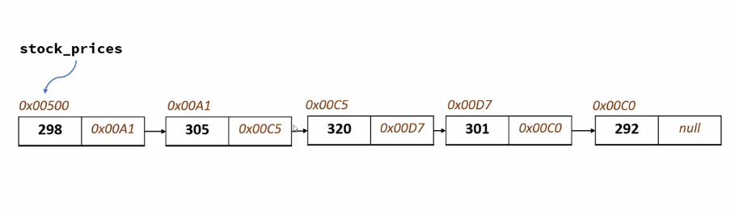

Note- The numbers starting with 0x…. Are the memory addresses. They refer to the next object’s address, where the data is located.

**A linked list object has two parts, data and next. Data contains the number etc, and next refers to the next object.**

2) Insertion is easier

If we want to insert a number at a certain place, it will take much less time and memory than a list, as a list puts a number at the desired position and moves all the elements to its right an index further.

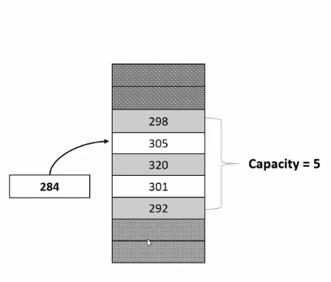

Note - If we wanted to insert 284 to our index number one, we would have to move indexes 2-5 one index.

Linked lists are different, they just change the reference to the new item and connect the previously connected item. This is visualized in the below diagram.

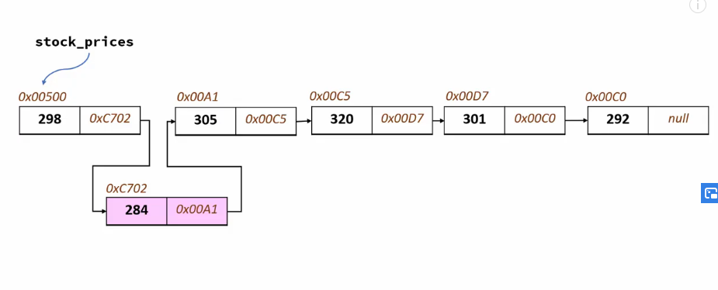

Note - Linked lists can also be doubly linked, which will enable us to iterate backwards.

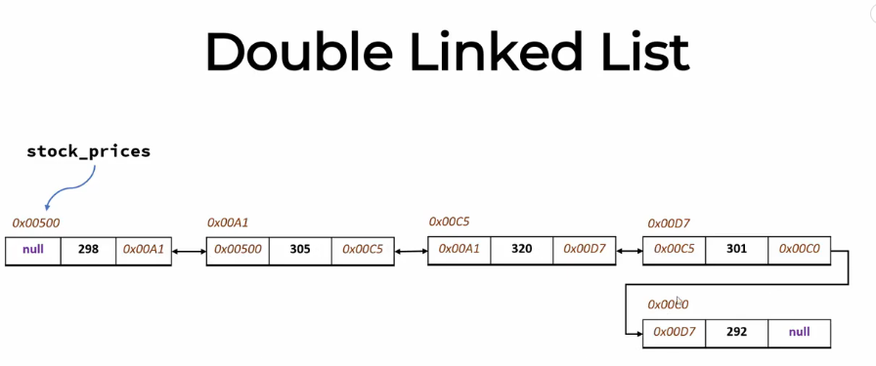

**Comparing Complexities of Lists and Linked Lists-**

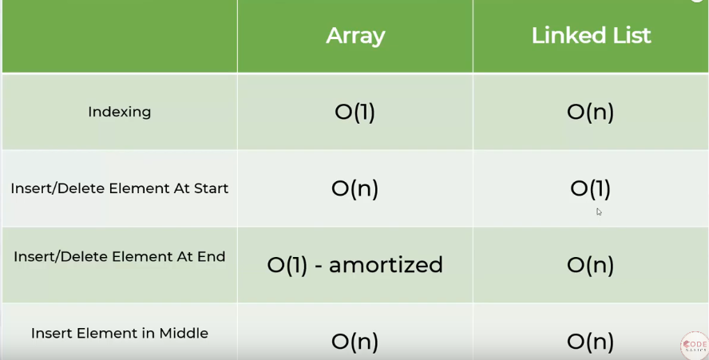

How to create a linked list?

* We basically create a Node, and then keep attaching nodes to it and then rename the one to be referring to None.
* The head node never has data, it just helps us to know the starting point of the list and is passed on during functions.

Algorithm for creating a Linked List-

* Create a **Node** class.
* Create a class **Linked List** which is a subclass of **Node.**
* Create a function to iterate over the values to be added and link them to the nodes.
* Name the last node as None**.**

**###** Linked lists can have functions as needed. Very common ones are - adding a data, removing a data, finding the size of the linked list, checking if a data is in this list and so on.

**Python Implementation of Linked List -**

##Linked list method to insert at the beginning of the list -

Algorithm - We first assign the new node’s next pointer to the current head of the linked list.

**def Insert_At_Beginning(self,data):**

**# We create a node, and put it in between the head and previous head.next node**

cur = self.head

next_node = cur.next

new_node = Node(data)

new_node.next = next_node

cur.next = new_node

##Linked list method to insert at the end of the list -

**def insert(self,data):**

new_node = Node(data)

cur = self.head

while cur.next != None:

cur = cur.next

cur.next = new_node

**self.count += 1 #<-- This line makes it easy to get the sizeof the list**

##Linked List method to get the size of the list -

**def size(self):**

return self.count #**#<-- Due to our use of count in the list, we canjust return count to get the size**

**def display(self):**

**#We basically create a list, and traverse the linked list and append to the list, and then print the list.**

arr = []

cur = self.head

while cur.next != None:

cur = cur.next

arr.append(cur.data)

return arr

**####Get functions checks for the index and prints the value of the node’s data.**

**def get(self,index):**

if index >= self.size() or index < 0: # added 'index<0' post-video

print("ERROR: 'Get' Index out of range!")

return None

cur_idx = 0

cur = self.head

while True:

cur = cur.next

if cur_idx == index: return cur.data

cur_idx += 1

**##Remove function starts from the start and traverses till it finds a node which has the same data as the input, and then removes it accordingly.**

**def remove(self,data):**

cur = self.head

while cur.next.data != data:

cur = cur.next

next_node = cur.next

next2 = next_node.next

cur.next = next2

**### Final Code for Python Linked List implementation-**

**class Node:**

def __init__(self,data = None):

self.data = data

self.next = None

**class LinkedList:**

**def __init__(self,count = 0):**

self.head = Node()

self.count = 0

## The above line creates an empty node and sets it as head

#The insert Method first creates a node, and then traverses across the list till it finds None and then attaches the new node.

**def insert(self,data):**

new_node = Node(data)

cur = self.head

while cur.next != None:

cur = cur.next

cur.next = new_node

self.count += 1

**def size(self):**

return self.count

**def display(self):**

arr = []

cur = self.head

while cur.next != None:

cur = cur.next

arr.append(cur.data)

return arr

**def Insert_At_Beginning(self,data):**

cur = self.head

next_node = cur.next

new_node = Node(data)

new_node.next = next_node

cur.next = new_node

#Get function basically helps us check the value using an index position. It does not remove the value from the Linked List

**def get(self,index):**

if index >= self.size() or index < 0: # added 'index<0' post-video

print("ERROR: 'Get' Index out of range!")

return None

cur_idx = 0

cur = self.head

while True:

cur = cur.next

if cur_idx == index: return cur.data

cur_idx += 1

#Remove function starts from the start and traverses till it finds a node which has the same data as the input, and then removes it accordingly.

**def remove(self,data):**

cur = self.head

while cur.next.data != data:

cur = cur.next

next_node = cur.next

next2 = next_node.next

cur.next = next2

l = LinkedList()

n = int(input())

for _ in range(n):

l.insert(int(input()))

print("The size of the Linked List is {}".format(l.size()))

l.Insert_At_Beginning(3)

l.display()

**#References used for the notes creation -**

**Important links -** [**https://www.tutorialspoint.com/python_data_structure/python_linked_lists.htm**](https://www.tutorialspoint.com/python_data_structure/python_linked_lists.htm)

[**https://www.tutorialspoint.com/python_data_structure/python_linked_lists.htm**](https://www.tutorialspoint.com/python_data_structure/python_linked_lists.htm)

**https://www.youtube.com/watch?v=JlMyYuY1aXU&t=531s**